Becky Taylor
1000373973
Physics 1444-004
04/01/2015

Laboratory Unit 18

Introduction: This lab was meant to familiarize the students with the use of certain measurement equipment and to demonstrate the results of different types of faults and their effects on a circuit. In order to adequately analyze the faults and their effects, the students must be familiar with Kirchoff’s laws. These laws can be used to analyze different points in a complex circuit that contains more than one voltage source and/or multiple resistors.

According to Kirchoff’s Laws:

At any node in a circuit, the sum of the currents flowing into the node is equal to the sum of the circuits flowing out of the node.

And

The sum of the products of the resistances, of the conductors and the currents in them in a closed loop is equal to the total emf of the loop.

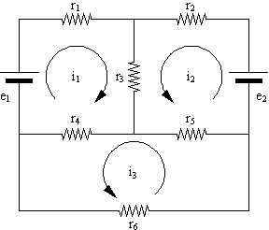

In this example of Kirchoff’s Laws, the node at the top, center would have I1 coming in and I2 and I3 leaving, therefor, I2+I3=I1. Also, just below that, I3=I4+I5 and I2=I5+I6 and so on.

In Loop 1, e1-r1(i1)-r3(i3)-r4(i4)=0
In Loop2, e2-R2(i2)-r3(i3)-r5(i5)=0

Using this information, you can set up a matrix and solve for the different variables in the circuit.

Objective: To measure the resistance, voltage and current at different points in a circuit using a multimeter and to use those measurements to estimate different types of faults. Then using that knowledge to analyze the current in different points in the circuit.

Procedure: To begin the lab, we set up the circuit given to us with no faults. The circuit was as follows:
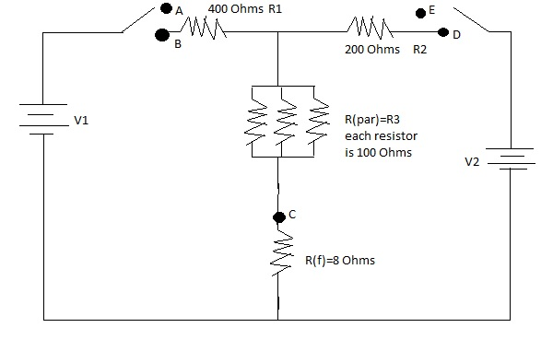
Because the back of the black box for the circuit was labeled 3V, we decided it was best to use 3 volts as the voltage and connected a DC power source to the circuit before we began our measurements. First, with all faults set to the “OFF” position, we left the switches both open so that there would be no voltage in the circuit and measured the resistance using the multimeter, connected from B to C, then from B to D and from D to C. The results of this are shown in the table on data sheet #1. We also calculated the values of the resistors, those in series (1 and 2) and those in parallel (3) and compared our expected results to the readings from the multimeter. The readings were within expected margins of error so we proceeded.

Next, we measured the voltages in each loop. We connected the meter to point A and point C. We left the AB switch open and closed the DE switch. We then connected the multimeter to the E and C points and closed the AB switch and opened the DE switch to measure the voltage on that side of the circuit. We recorded these values. We recorded these voltages using the 20V setting.

After this, it was time to measure the current on each of the loops. We had to switch the red probe on the multimeter to the mA ɥA socket. We set the range at 200 mA. We connected the probes to the A and B points, with the AB switch open and the DE switch closed to complete the circuit and measured the current on this side. We recoded this as I1. We repeated the process with the point D and E with the DE switch opened and the AB class closed. We recorded this reading as I2.

Then, using the calculated resistance values and the measured voltages, we calculated the values of the current at I1, I2 and I3. Here is an illustration of the branches of the circuit with both the loops and the currents labeled:

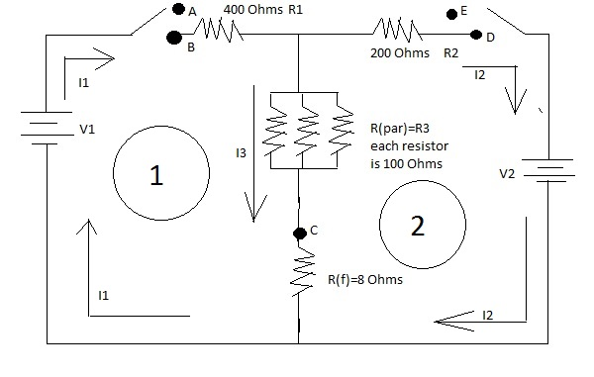
So, with I used the following formulas:

I1+I2-I3=0
I1R1+I3R3=V1
I2R2+I3R3=V2

Using a matrix, the measured values of the voltages and the given values of the resistors, I calculated the value of the currents and recorded them on the table on Data Sheet 1.

After this, we repeated this process with each fault switched on in turn, using our measurements to estimate the nature and location of each fault. Below are drawings of each of the faults.

Data Sheet 2 estimated fault:

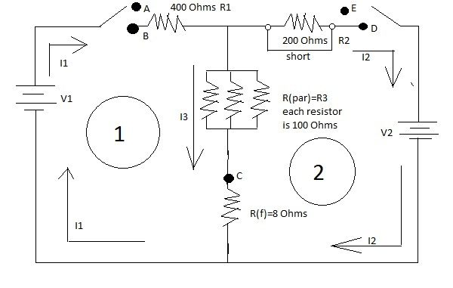
Data Table 3 Estimated Fault:

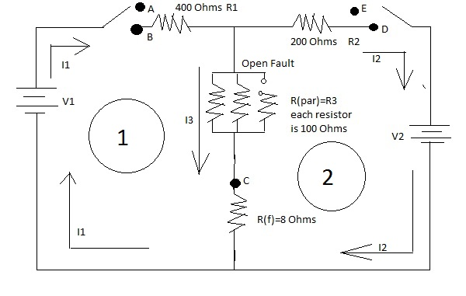
Data Table 4 estimated Vault.
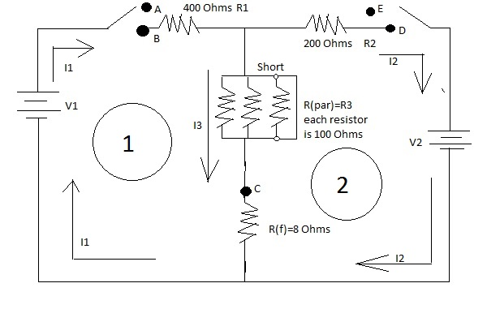
Summary: Adding up the resistances measured, it became easy to estimate each of the faults, and using Kirchoff’s rule, I was able to repeat use of the same matrix I had already constructed to solve for the current in each of the other instances. Over all, this exercise gave me a good practice of using and a better understanding of Kirchoff’s laws.

